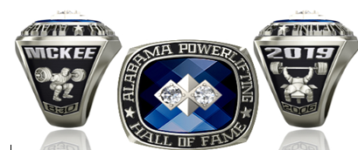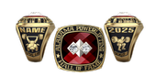

WHITE LUSTRIUM SUNCAST

NAME: _______________________________________
ADDRESS: ____________________________________
CITY: _________________ STATE: _____ ZIP:_______
PHONE: _____________________________

CHECK TWO EVENTS: BENCH PRESS_______ DEADLIFT_______ SQUAT________
TOTALS (OPTIONAL): BENCH PRESS_______ DEADLIFT_______ SQUAT________

YEAR/DATE INDUCTED: _________ STONE COLOR______________

FINGER SIZE: _________ (Email scott.moore@jostens.com if you need finger size ruler)

NAME OUTSIDE_____________ INSIDE ENGRAVING_____________________________

METAL CHOICE:
____White Lustrium $399 ____ Suncast $499 (call for 10kt pricing)

7 – 9 WEEK DELIVERY *PRICES INCLUDE TAX and SHIPPING

Jostens mailing address: 850 Union Chapel Rd. East (Unit 9) Northport, AL 35473
Phone: 205-233-1945
Email at scott.moore@jostens.com

